

1. **WIREFRAME FOR DASHBOARD**

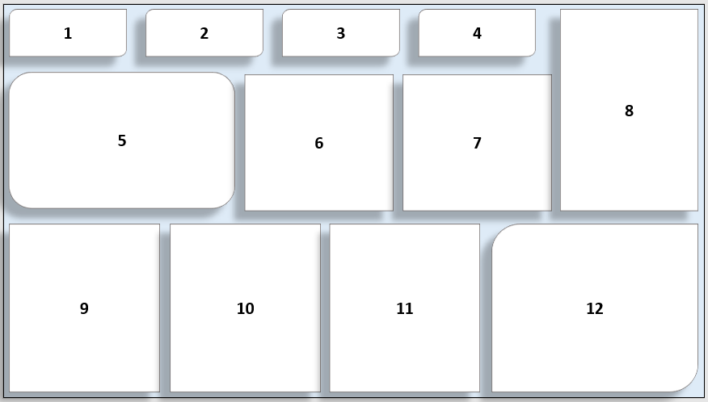

Raw sketch of Dashboard

**INDICATIONS :**

1. Total Start up company with the % of PE funded (***KPI***)
2. Total investment in $ (***KPI***)
3. Total number of investor (***KPI***)
4. Total number of tier 1 investor (***KPI***)
5. Startup companies in top 5 county and themes (***Bar chart***)
6. Top N investors on count of Startup (***Tree map***)
7. Sector wise total investment amount raised till date (***Bubble chart***)
8. Filters box
9. Top 10 theme on Count of Startup (***Horizontal bar chart)***
10. Stage of level wise total amount rised till date (***Bubble chart***)
11. Sector wise Board themes (***Heat map***)
12. Start up companies in top 5 countries and theme (***Bar chart***)

**COLOUR CODE:**

Darker color of blue indicates that the range of value is ***maximum***

Orange color indicates ***No for PF funded***

Darker navy-blue color indicates ***Yes for PF funded***

Lighter color of blue or white color indicates that the range of value is ***minimum***

*Some other colours may use for visualization.

**DASHBOARD WITH SAMPLE DATA**

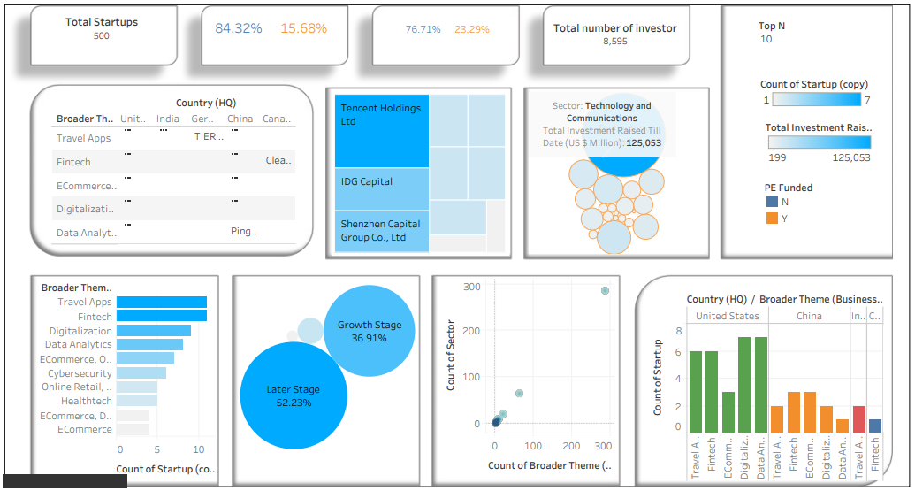

1. **ESTIMATION AND POC**

* Creating Wireframe for Dash Board = 2 Hr
* Data Understanding and Cleaning = 3 Hr
* Data Exploring and Preparation = 3 Hr
* Tool used for Visualization: Tableau public
* Build a creative interactive Dashboard = 4 Hr
* Insight story from the Dashboard = 1 Hr
* Solution for the problem = 2Hr
  + Total Hours = **15**
  + For 1 Hr = 600 rupees
  + Total Estimated Amount = 15 * 600 = **9000 rupees**